Yang Cheng Fu and Dong Ying Jie Comparative Postures
Yang Style Traditional Slow Set
First Section
(Some moves not shown)

Yang Cheng Fu (Left) and Dong Ying Jie (Tung Ying Chieh) (Right)
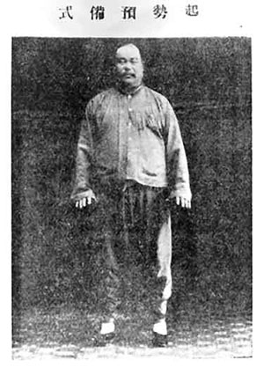 | 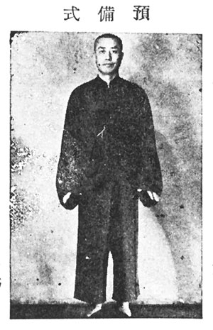
(Yu Pei Shih)
Preparation position
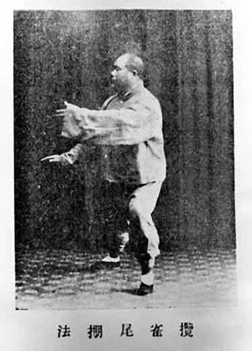 | 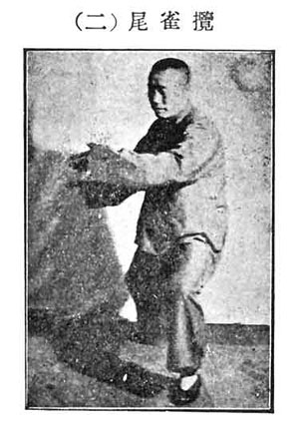
(Lan Ch’iao Wei)
Grasp the bird’s tail
Left Move
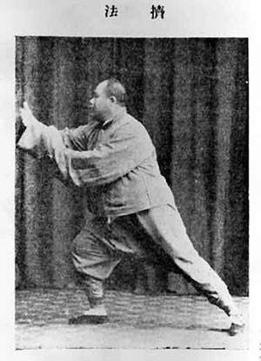 | 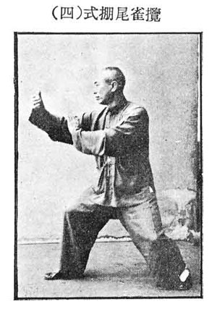
(Lan Ch’iao Wei)
Grasp the bird’s tail
Ward Off Upward
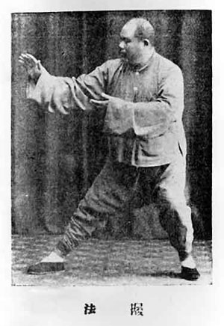 | 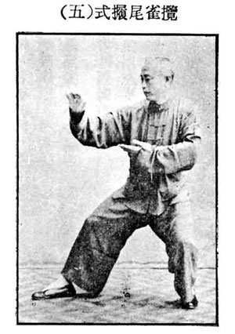
(Lan Ch’iao Wei)
Grasp the bird’s tail
Pull Back
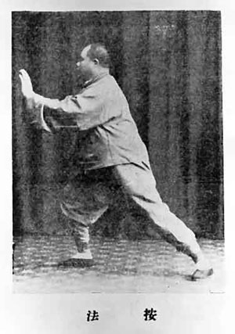 | 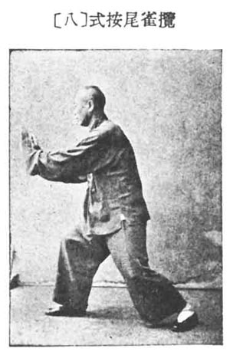
(Lan Ch’iao Wei)
Grasp the bird’s tail
Push
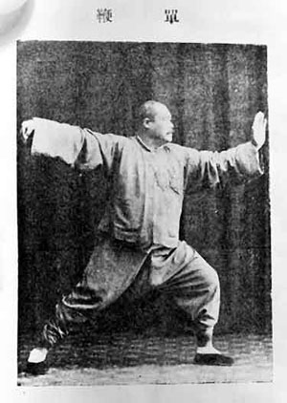 | 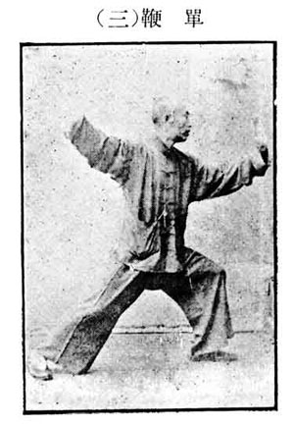
(Tan Pien)
Single whip
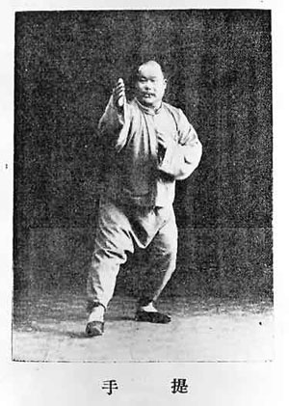 | 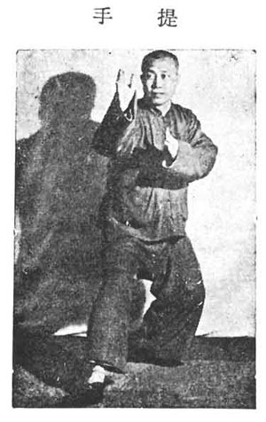
(Ti Shou Shang Shih)
Step forward and raise hands
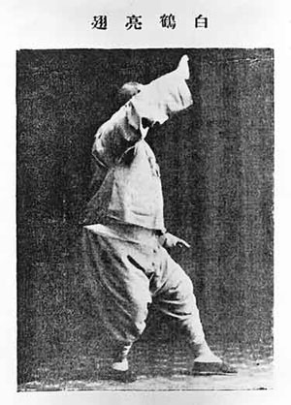 | 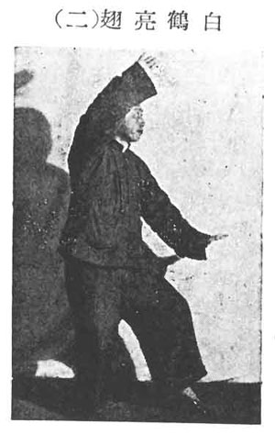
(Pai Hao Liang Chih)
White stork spreading its wing
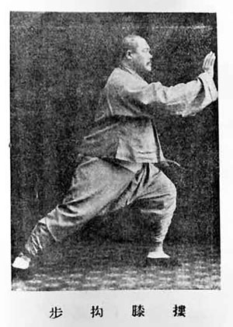 | 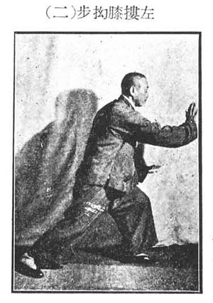
(Lou Sih Au Pu)
Brush knee and twist step
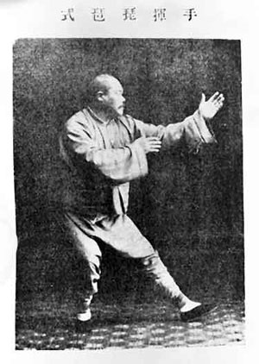 | 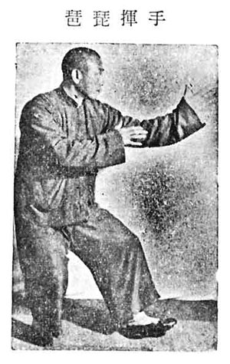
(Shou Hui P’i P’a)
Play the fiddle
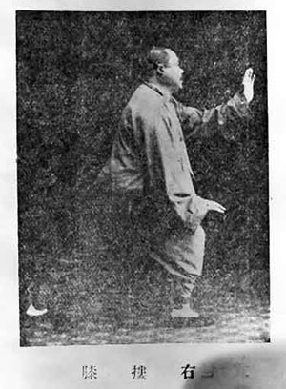 | 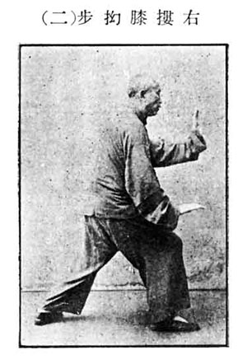
(Tso Yu Lou Sih Au Pu)
Brush knee and twist step
Brush right knee
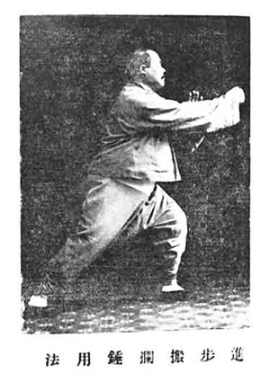 | 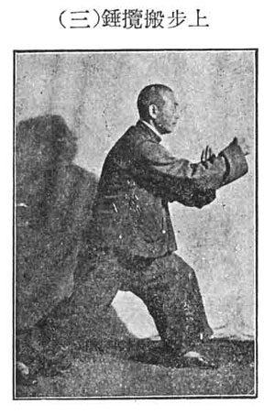
(Chin Pu Pan Lan Ch’ui)
Step up, deflect downward, parry and punch
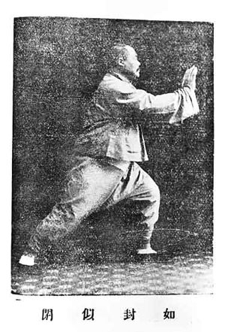 | 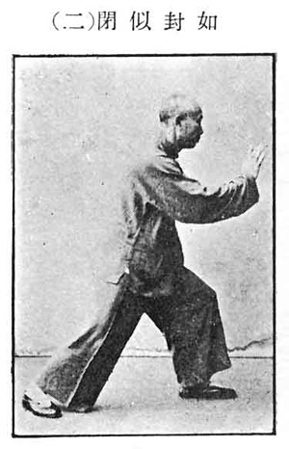
(Ju Feng Shih Pi)
Apparent close up
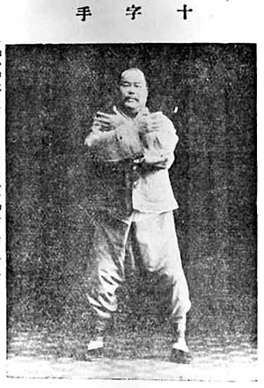 | 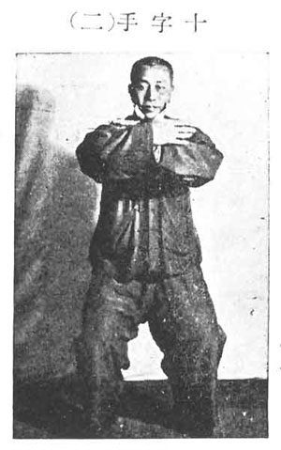
(Shih Tzu Shou)
Cross hands
Yang Cheng Fu and Dong Ying Jie Comparative Postures
Yang Style Traditional Slow Set
First Section
(Some moves not shown)

Yang Cheng Fu (Left) and Dong Ying Jie (Tung Ying Chieh) (Right)
(Yu Pei Shih)
Preparation position
(Lan Ch’iao Wei)
Grasp the bird’s tail
Left Move
(Lan Ch’iao Wei)
Grasp the bird’s tail
Ward Off Upward
(Lan Ch’iao Wei)
Grasp the bird’s tail
Pull Back
(Lan Ch’iao Wei)
Grasp the bird’s tail
Push
(Tan Pien)
Single whip
(Ti Shou Shang Shih)
Step forward and raise hands
(Pai Hao Liang Chih)
White stork spreading its wing
(Lou Sih Au Pu)
Brush knee and twist step
(Shou Hui P’i P’a)
Play the fiddle
(Tso Yu Lou Sih Au Pu)
Brush knee and twist step
Brush right knee
(Chin Pu Pan Lan Ch’ui)
Step up, deflect downward, parry and punch
(Ju Feng Shih Pi)
Apparent close up
(Shih Tzu Shou)
Cross hands
Yang Cheng Fu and Dong Ying Jie Comparative Postures
Yang Style Traditional Slow Set
First Section
(Some moves not shown)

Yang Cheng Fu (Left) and Dong Ying Jie (Tung Ying Chieh) (Right)
(Yu Pei Shih)
Preparation position
(Lan Ch’iao Wei)
Grasp the bird’s tail
Left Move
(Lan Ch’iao Wei)
Grasp the bird’s tail
Ward Off Upward
(Lan Ch’iao Wei)
Grasp the bird’s tail
Pull Back
(Lan Ch’iao Wei)
Grasp the bird’s tail
Push
(Tan Pien)
Single whip
(Ti Shou Shang Shih)
Step forward and raise hands
(Pai Hao Liang Chih)
White stork spreading its wing
(Lou Sih Au Pu)
Brush knee and twist step
(Shou Hui P’i P’a)
Play the fiddle
(Tso Yu Lou Sih Au Pu)
Brush knee and twist step
Brush right knee
(Chin Pu Pan Lan Ch’ui)
Step up, deflect downward, parry and punch
(Ju Feng Shih Pi)
Apparent close up
(Shih Tzu Shou)
Cross hands
Yang Cheng Fu and Dong Ying Jie Comparative Postures
Yang Style Traditional Slow Set
First Section
(Some moves not shown)

Yang Cheng Fu (Left) and Dong Ying Jie (Tung Ying Chieh) (Right)
(Yu Pei Shih)
Preparation position
(Lan Ch’iao Wei)
Grasp the bird’s tail
Left Move
(Lan Ch’iao Wei)
Grasp the bird’s tail
Ward Off Upward
(Lan Ch’iao Wei)
Grasp the bird’s tail
Pull Back
(Lan Ch’iao Wei)
Grasp the bird’s tail
Push
(Tan Pien)
Single whip
(Ti Shou Shang Shih)
Step forward and raise hands
(Pai Hao Liang Chih)
White stork spreading its wing
(Lou Sih Au Pu)
Brush knee and twist step
(Shou Hui P’i P’a)
Play the fiddle
(Tso Yu Lou Sih Au Pu)
Brush knee and twist step
Brush right knee
(Chin Pu Pan Lan Ch’ui)
Step up, deflect downward, parry and punch
(Ju Feng Shih Pi)
Apparent close up
(Shih Tzu Shou)
Cross hands
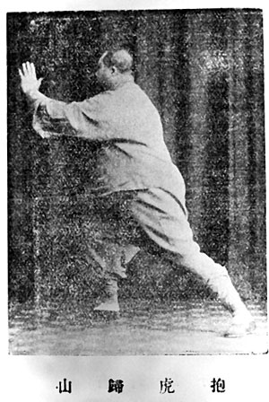 | 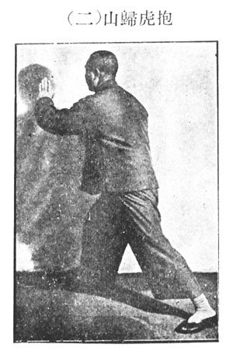
Pao Hu Kwei Shan)
Carrying tiger to the mountain
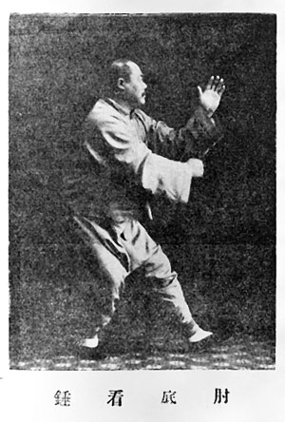 | 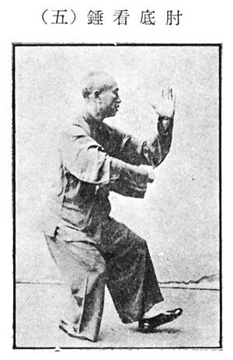
(Chou Ti K’an Ch’ui)
Fist under elbow (5-moves)
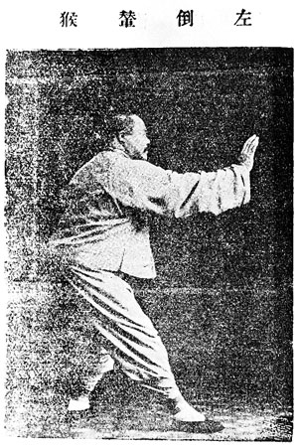 | 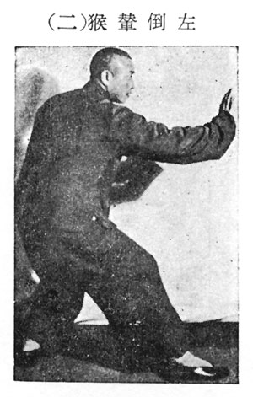
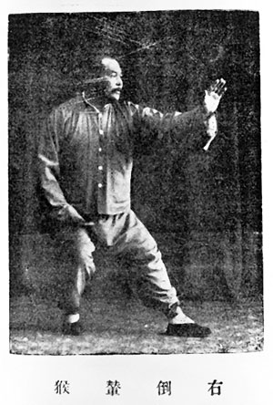 | 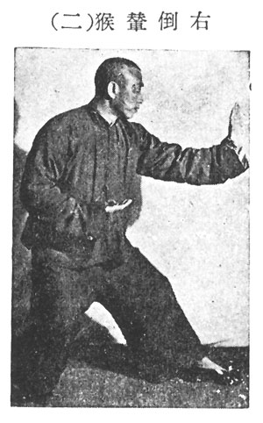
(Tso Yu Tao Nien Hou)
Step back and repulse monkey
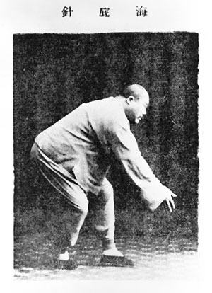 | 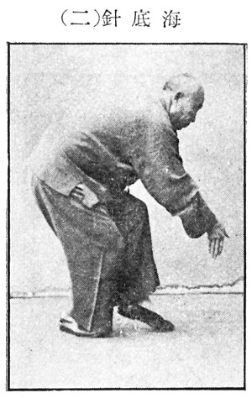
(Hai Ti Chen)
Needle at bottom of sea
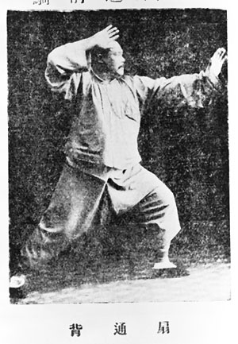 | 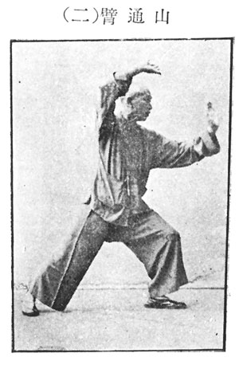
(Shan Tung Pei)
Push through the mountain
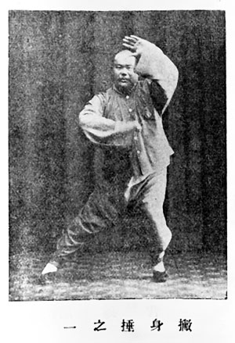 | 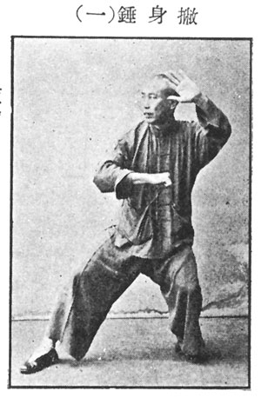
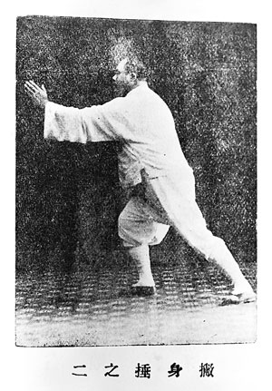 | 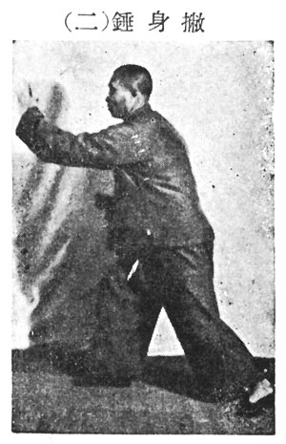
(P’i Shen Ch’ui)
Chop opponent with fist
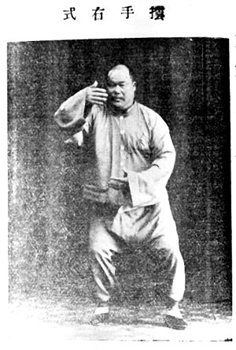 | 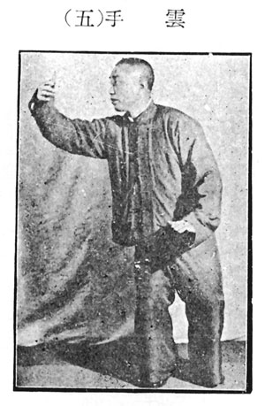
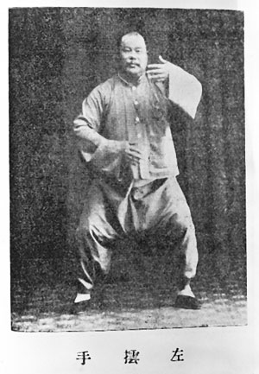 | 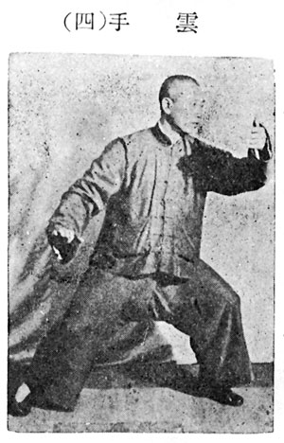
(Yun Shou)
Wave hands like clouds
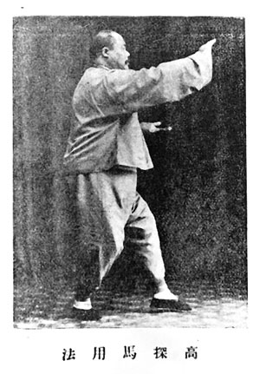 | 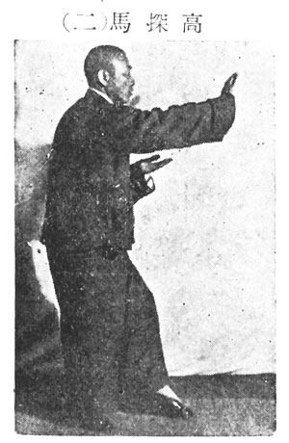
(Kao T’an Ma)
High pat on horse
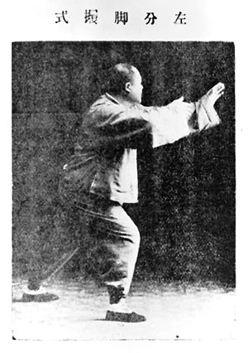 | 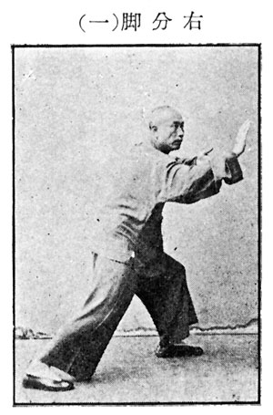
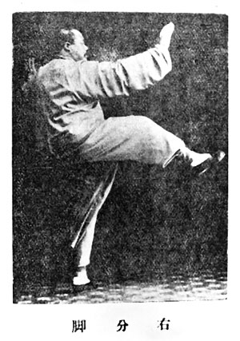 | 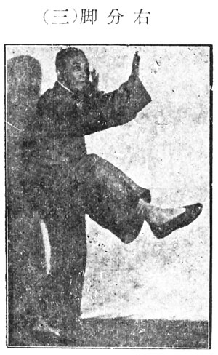
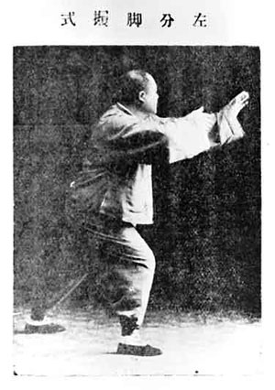 | 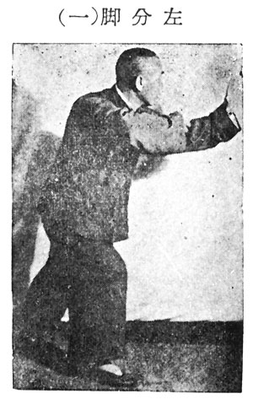
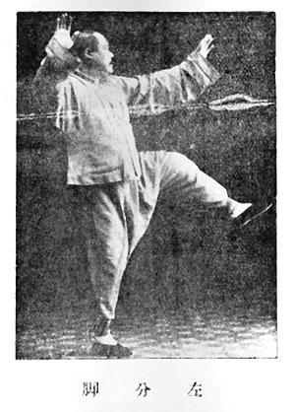 | 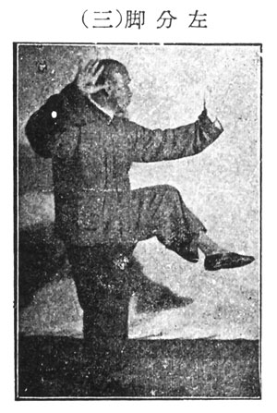
(Tso Yu Fen Chiao)
Separation of left and right foot
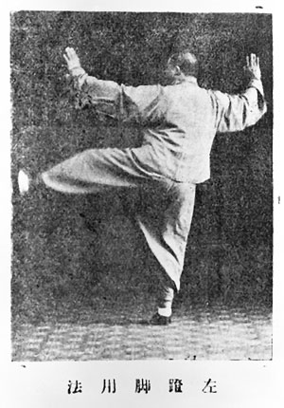 | 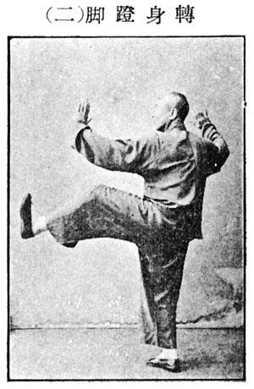
(Chuan Shen Teng Chiao)
Turn and kick with sole
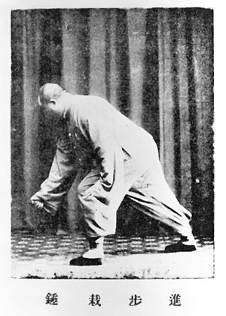 | 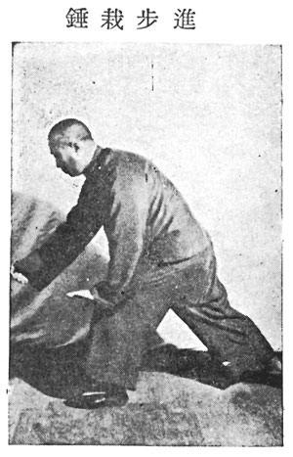
(Chin Pu Tsai Ch’ui)
Step up and punch downward
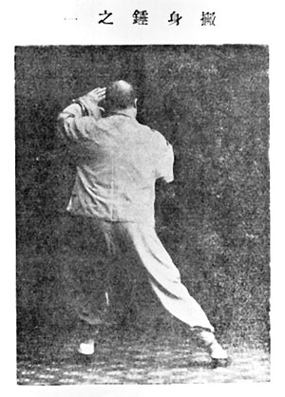 | 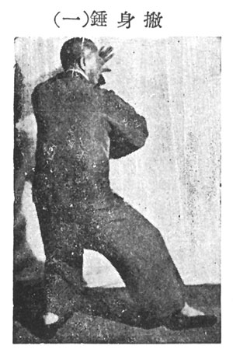
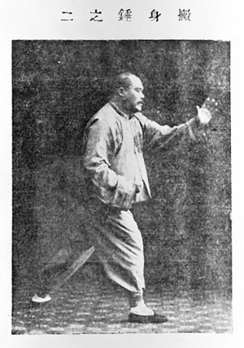 | 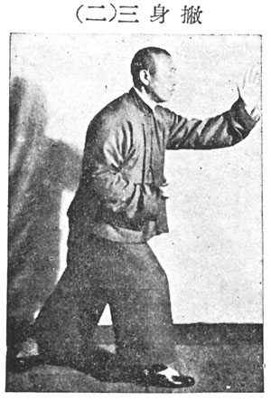
(P’i Shen Ch’ui)
Chop opponent with fist
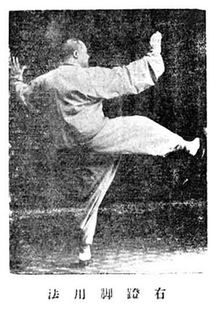 | 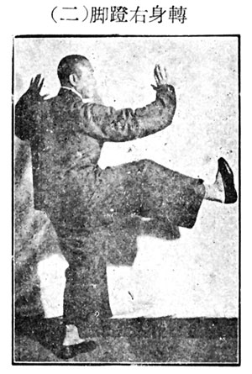
(Hsia Shen Pu Teng Chiao)
Slanting body and right foot kicks upward
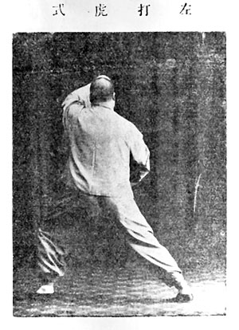 | 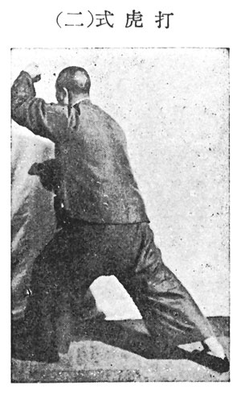
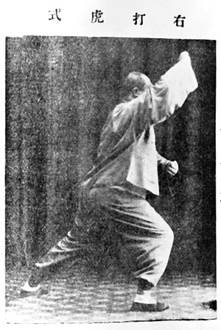 | 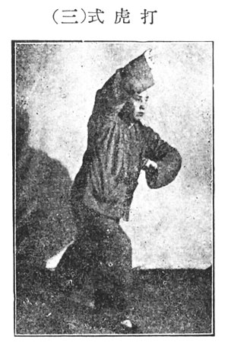
(Tso Yu Ta Hu Shih)
Hit tiger at left and right
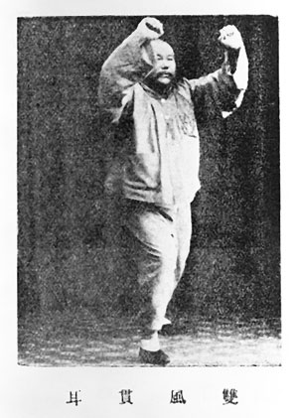 | 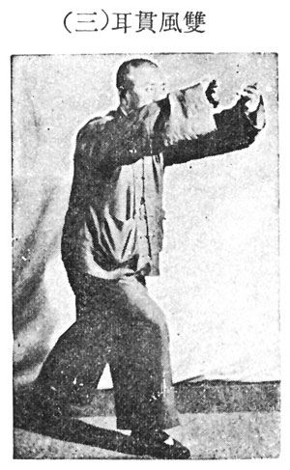
(Shuang Feng Kuan Er)
Strike opponent’s ears with both fists
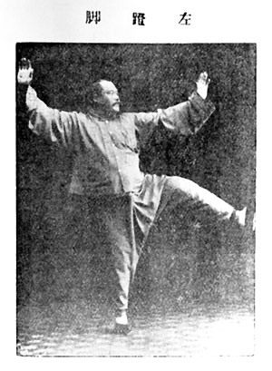 | 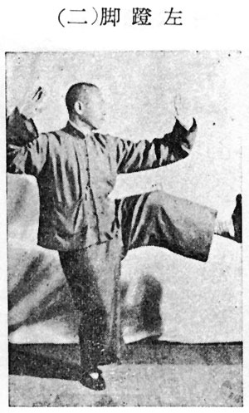
(Tso Teng Chiao)
Left foot kicks upward
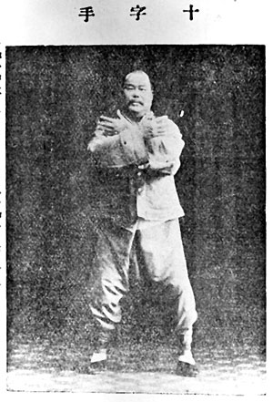 | 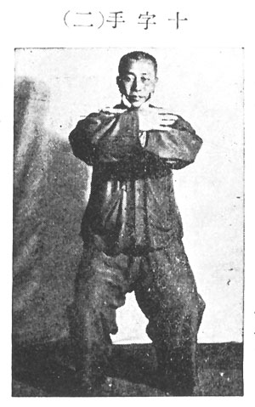
(Shih Tzu Shou)
Cross hands
(Shih Tzu Shou)
Cross hands
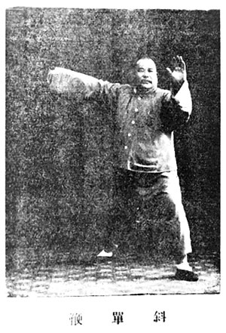 | 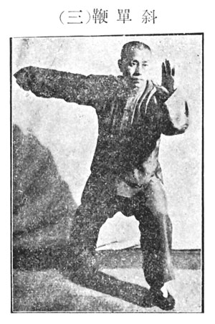
(Hsia Tan Pien)
Slanting single whip
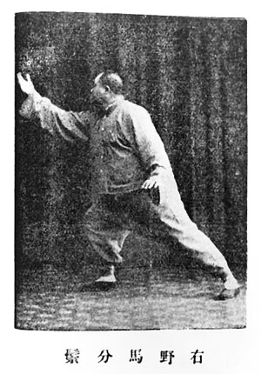 | 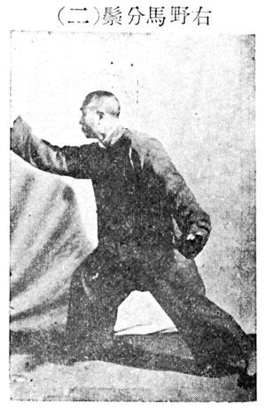
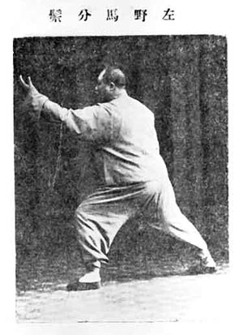 | 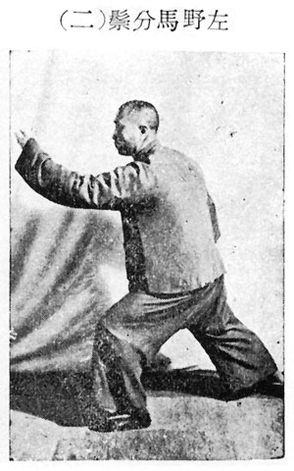
(Tso Yu Yeh Ma Fen Tsung)
Separating the wild horse’s mane
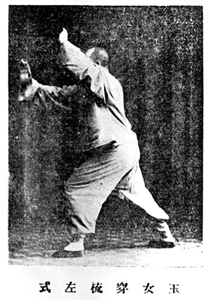 | 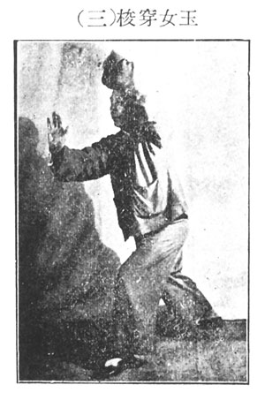
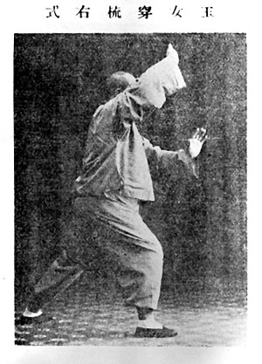 | 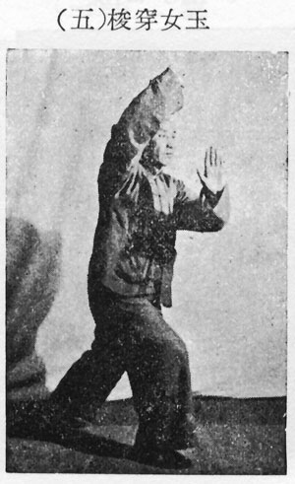
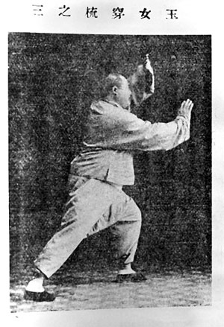 | 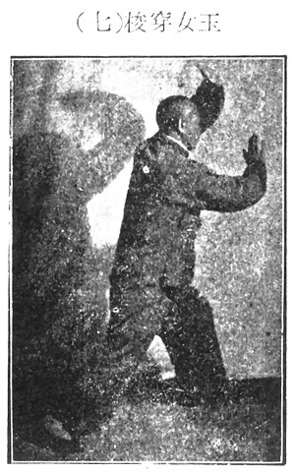
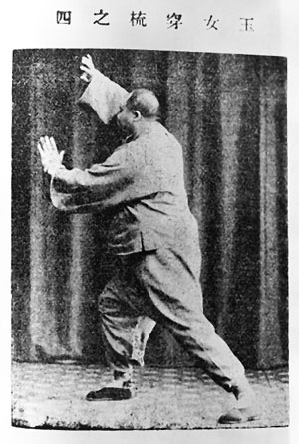 | 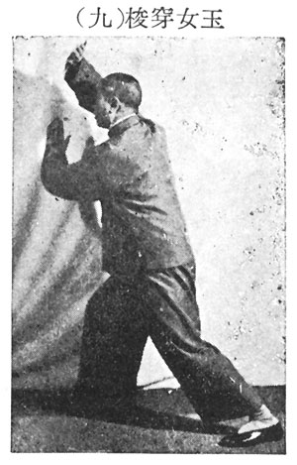
(Mai Nu Ch’uan Shu)
Fair lady works the shuttles 1,2,3, and 4
(Four corners)
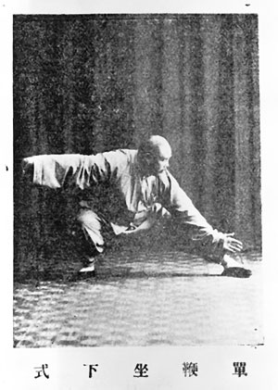 | 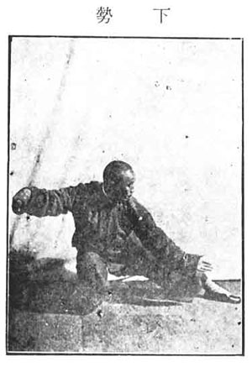
(Tan Pien Hsia Shih)
Single whip and snake creeps down
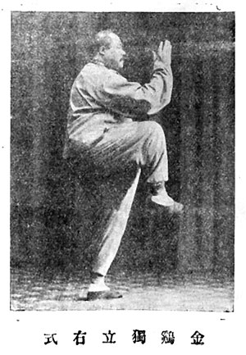 | 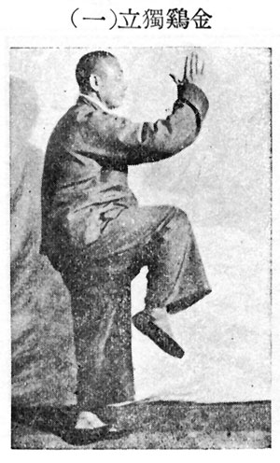
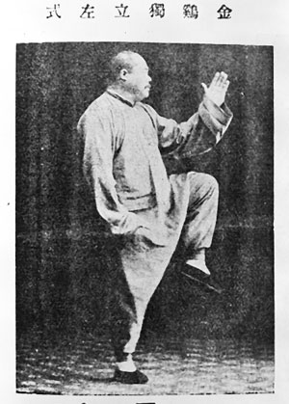 | 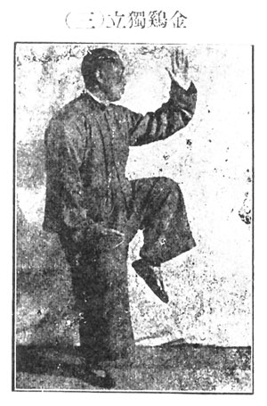
Chin Chi Tu Li)
Golden cock stands on one leg
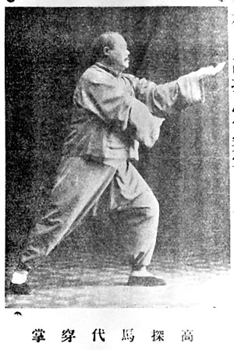 | 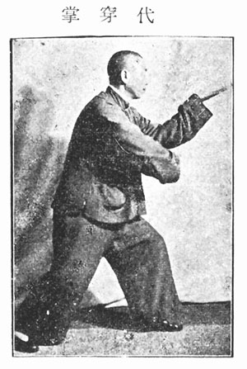
(Kao T’an Ma Dai Ch’uan Jang)
High pat on horse and hit opponent with left hand
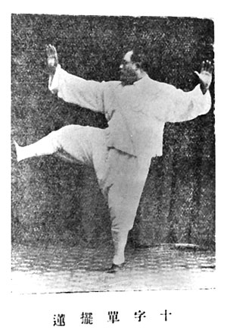 | 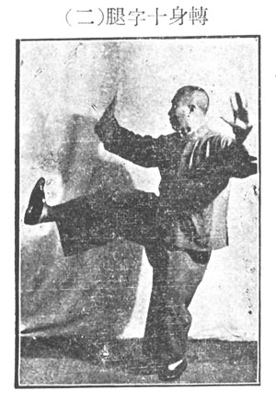
(Chuan Shen Shih Tzu T’ui)
Turn and kick with right foot
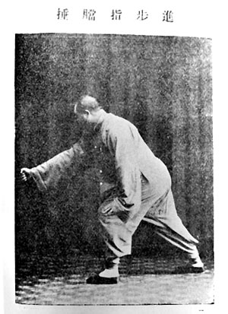 | 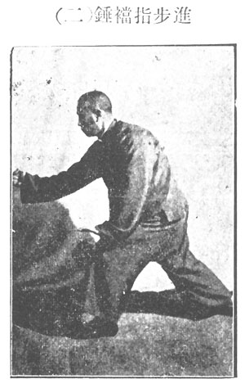
(Chin Pu Chi Tang Ch’ui)
Step up and punch opponent’s public region
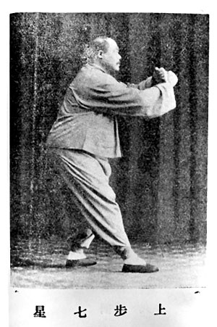 | 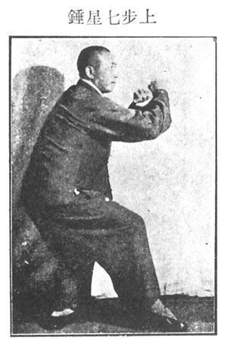
(Shang Pu Chi Hsing Ch’ui)
Step up to form seven stars punch
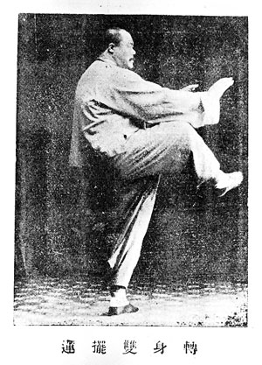 | 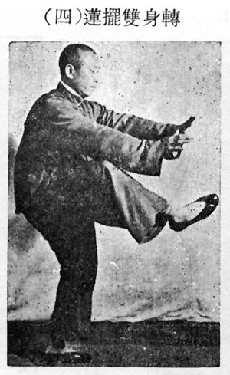
(Chuan Shen Shang Pai Lien)
Turn around and kick horizontally
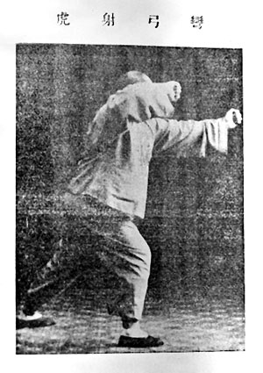 | 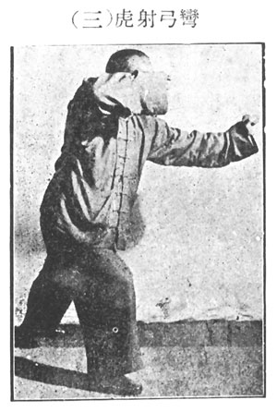
(Wan Kung She Hu)
Shoot tiger with bow
(Shih Tsu Shou He T’ai Chi)
Cross hands and conclusion of T’ai Chi

